Color Space Conversion

HSV

RGB  
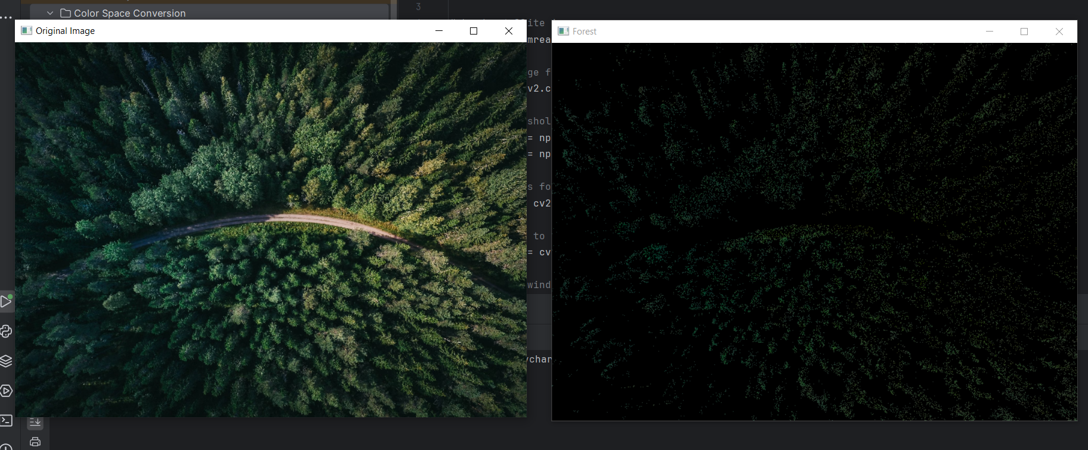

CompressedIMG

K-mean Clustering

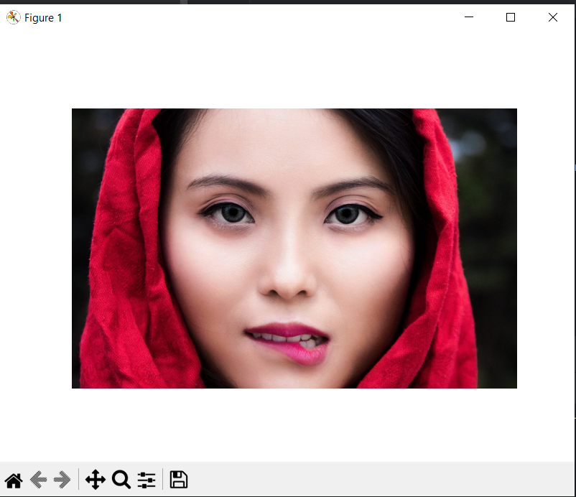

Texture Analysis





